Software Architecture Description

Revision History
Rev | Date | Revision History
00 | 2025.02.28 | First Issued.

Contents
1. Software Systems 7
2. Software Units 7
3. Database 9

1. Software Systems
In compliance with DIN EN 62304, we subdivide our software on three levels: software systems, software components and software units.
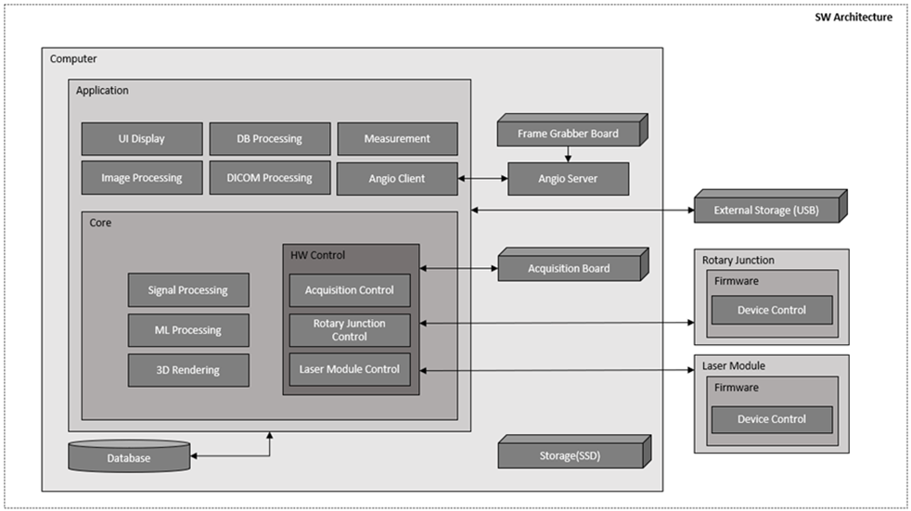

2. Software Units
1) UI Display
- Visually presents analysis results through the User Interface (UI).
- Provides intuitive access to OCT images, 3D rendering, and analysis data.
- Designed with a Graphical User Interface (GUI) to allow medical professionals to easily view and manipulate data.
2) DB Processing
- Stores and manages analysis results and patient data in a database (DB).
- Performs functions for saving and retrieving patient OCT examination records.
3) Measurement
- Performs quantitative measurements such as vessel diameter, lesion length, and stent position in OCT images.
- Supports AI-based automatic measurement to improve analysis accuracy.
- Provides an interface for medical professionals to manually add additional measurements.
4) Image Processing
- Preprocesses and enhances OCT images, including noise removal and contrast enhancement.
5) DICOM Processing
- Stores OCT data in compliance with the DICOM standard.
6) Angio Client
- Synchronizes X-ray angiography (Angiography) data with OCT images for analysis.
- Provides vascular path tracking functionality based on angiography.
- Supports merging and interpretation of OCT images and angiography data for medical professionals.
7) Signal Processing
- Processes OCT signal data to generate high-quality images.
8) ML Processing
- Performs AI/ML-based automated lesion analysis on OCT images.
- Applies deep learning models to detect vascular contours, stents, calcium deposits, and vessel landmarks.
9) 3D Rendering
- Generates a 3D model of blood vessels based on OCT data.
- Provides visualization to intuitively identify lesion locations and vascular structures.
- Supports real-time 3D manipulation, including zoom, rotation, and cross-sectional viewing.
10) Acquisition Control
- Manages and optimizes the OCT data acquisition process.
11) Rotary Junction Control
- Controls the rotational system of the OCT catheter to ensure uniform image acquisition.
- Adjusts rotation speed to maintain optimal imaging conditions.
12) Laser Module Control
- Controls the laser module of the OCT system to optimize image quality.
- Performs laser wavelength and output adjustments, as well as signal synchronization functions.

3. Database
- Relational database: PostgreSQL v14

Template Copyright openregulatory.com. See template license.
Please don’t remove this notice even if you’ve modified contents of this template.

